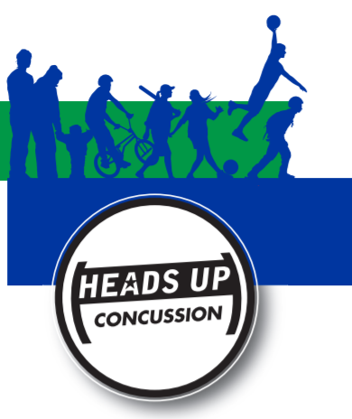
P
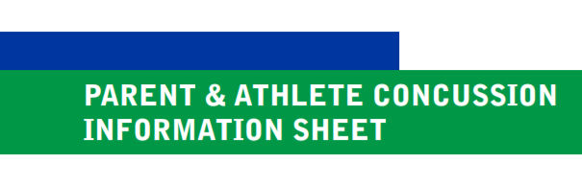

WHAT IS A CONCUSSION?
A concussion is a type of traumatic brain injury that
changes the way the brain normally works. A concussion
is caused by a bump, blow, or jolt to the head or body that causes the head and brain to move quickly back and forth. Even a ding, ”getting your bell rung,” or what seems to be a mild bump or blow to the head can be serious.
WHAT ARE THE SIGNS AND
SYMPTOMS OF CONCUSSION?
Signs and symptoms of concussion can show up right after the injury or may not appear or be noticed until days or weeks after the injury.
If an athlete reports one or more symptoms of concussion after a bump, blow, or jolt to the head or body, s/he should be kept out of play the day of the injury.The athlete should only return to play with permission from a health care professional experienced in evaluating for concussion.
DID YOU KNOW?
• Most concussions occur without loss of
consciousness.
• Athletes who have, at any point in their lives, had a concussion have an increased risk for another concussion.
• Young children and teens are more likely to get a concussion and take longer to recover than adults.
SYMPTOMS REPORTED BY ATHLETE:
• Headache or “pressure” in head
• Nausea or vomiting
• Balance problems or dizziness
• Double or blurry vision
• Sensitivity to light
• Sensitivity to noise
• Feeling sluggish, hazy, foggy, or groggy • Concentration or memory problems • Confusion
• Just not “feeling right” or is “feeling down”
SIGNS OBSERVED
BY COACHING STAFF:
• Appears dazed or stunned
• Is confused about assignment or position • Forgets an instruction
• Is unsure of game, score, or opponent • Moves clumsily
• Answers questions slowly
• Loses consciousness (even briefly) • Shows mood, behavior, or personality changes • Can’t recall events prior to hit or fall • Can’t recall events after hit or fall

“IT’S BETTER TO MISS ONE GAME
THAN THE WHOLE SEASON”

CONCUSSION DANGER SIGNS
In rare cases, a dangerous blood clot may form on the brain in a person with a concussion and crowd the brain against the skull. An athlete should receive immediate medical attention if after a bump, blow, or jolt to the head or body s/he exhibits any of the following danger signs:
• One pupil larger than the other
• Is drowsy or cannot be awakened
• A headache that gets worse
• Weakness, numbness, or decreased coordination • Repeated vomiting or nausea
• Slurred speech
• Convulsions or seizures
• Cannot recognize people or places
• Becomes increasingly confused, restless, or agitated • Has unusual behavior
• Loses consciousness (even a brief loss of consciousness should be taken seriously)
WHAT SHOULD YOU DO IF YOU THINK YOUR ATHLETE HAS A CONCUSSION?
1. If you suspect that an athlete has a concussion, remove the athlete from play and seek medical attention. Do not try to judge the severity of the injury yourself. Keep the athlete out of play the day of the injury and until a healthcare professional, experienced in evaluating for concussion, says s/he is symptom-free and it’s OK to return to play.
2. Rest is key to helping an athlete recover from a concussion. Exercising or activities that involve a lot of concentration, such as studying, working on the computer, and playing video games, may cause concussion symptoms to reappear or get worse. After a concussion, returning to sports and school is a gradual process that should be carefully managed and monitored by a health care professional.
3. Remember: Concussions affect people differently. While most athletes with a concussion recover quickly and fully, some will have symptoms that last for days, or even weeks. A more serious concussion can last for months or longer.
WHY SHOULD AN ATHLETE REPORT THEIR SYMPTOMS?
If an athlete has a concussion, his/her brain needs time to heal. While an athlete’s brain is still healing, s/he is much more likely to have another concussion. Repeat concussions can increase the time it takes to recover. In rare cases, repeat concussions in young athletes can result in brain swelling or permanent damage to their brain. They can even be fatal.

STUDENT ATHLETE NAME:

PARENT NAME:

PARENT SIGNATURE:

DATE:

JOIN THE CONVERSATION www.facebook.com/CDCHeadsUp TO LEARN MORE GO TO >> WWW.CDC.GOV/CONCUSSION
Content Source: CDC’s Heads Up Program. Created through a grant to the CDC Foundation from the National Operating Committee on Standards for Athletic Equipment (NOCSAE).

